MEETING MINUTES
Meeting Time: 6:30 p.m.
Meeting Location: Bearspaw School Library (In-Person)
Attendees:
 | Andrea Craigie |  | Destin Skauge | R | Reena Vadan
R | Kendra Mogck |  | Jody Seerup | R | Darah Manhas
 | Judi Hunter (Trustee) |  | Ashley Beagle |  | Amber Brandt
 | Emma Lindsey | R | Sara Hughes |  | Tanya Glencross
 | Nicole Woodland | R | Supreet Dhillon | R | Sasha Wiens
 | Alison Foster | R | Chantal Borcelo |  | Chelsey Setter
R | Simrit Brar |  | Sierra Rogers |  | Kari Kasper
 | Stephanie Demers | R | Trudy Toews |  | Nicole Savoie

Agenda Item | Notes/Minutes
- Call to Order | Emma Lindsey (@6:30) – called to order
- Approval of Agenda | Agenda approved by Alison Foster
- Approval of Minutes | Minutes approved by Alison Foster
- Old Business | N/A
- Business Arising from Previous Minutes | None
- Staff Representative Report | Mr. Ben Ryan  Focus on: Indigenous Outdoor Education  - Camp Stove Cook Off: Bring Camp Stove and have a cooking contest  - Survival Kits  - How to use Bear Spray  - Building Shelters  - Planning a Big Trip  Goal is to make it Indigenous: What makes it Indigenous?  Goal is to learn from and off the land. Indigenous knowledge base is a lot of land based learning.  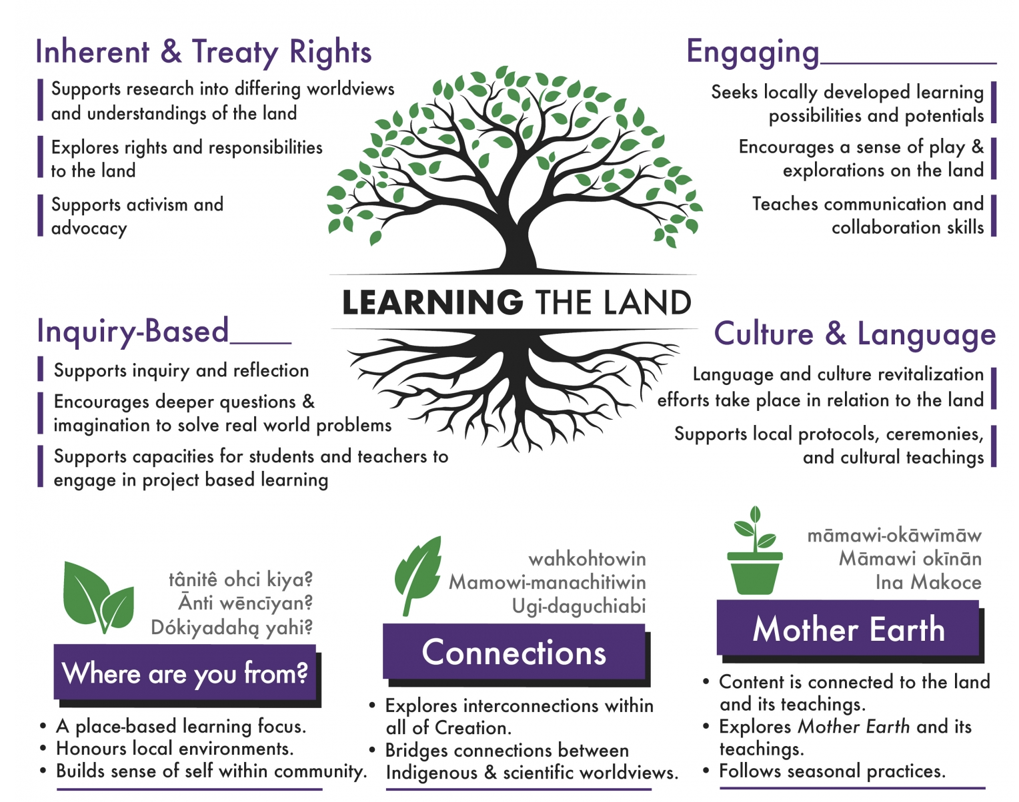  Activities that can be planned are weather dependent:  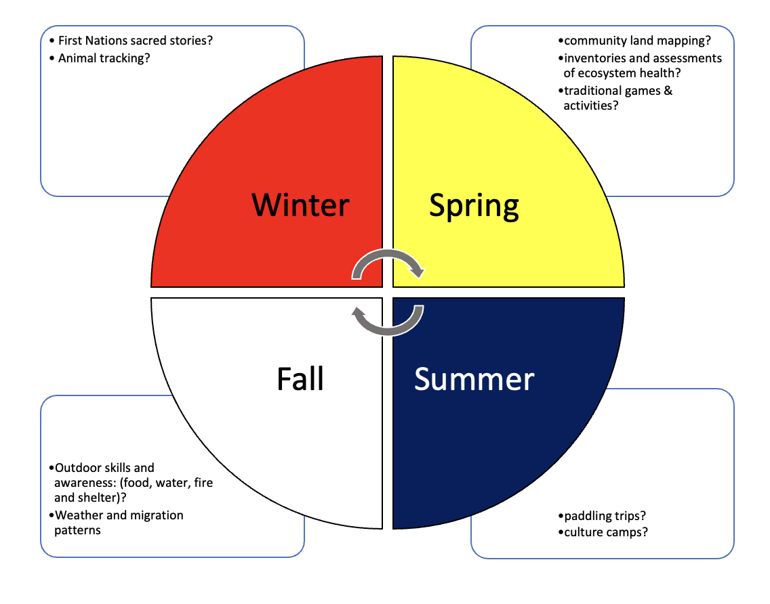  - Rockyview Indigenous Specialists will come in and help with teaching.  Smudging:  - Smudging is an indigenous ceremony where we are learning about resetting ourselves and hearing stories  - There will be smudging offered every term, students do not have to participate if they are not comfortable or their parents would prefer they do not  THE BIG TRIP:  - Goal is to book a trip to Blackfoot Crossing  - Blackfoot Crossing is a very important site in Indigenous history  - Chief Crowfoot is buried here  - Treaty 7 was signed here  - Students can even sleep in Tipi’s (weather permitting)
- Administration Report | Andrea Craigie  READ-A-THON:  Data gatherin and planning process now complete:    - Different formats for Read-a-Thons have been gathered and reviewed  - Spoke with Parents for perspective  - Reviewed all ideas with a subgroup of teachers  For the first yearthe plan is to start with a basic Read-a-Thon.  * Please reference the purple hand out for additional detail  School Council discussed the following:  - Review of hand out – ensure that School Council reviews and provides feedback on the instructions  - Determine subgroups to complete data analysis and prize collection post the Read-a-Thon. School Council volunteers to assist with this:  - Tanya Glencross  - Emma Lindsey  - Kari Kasper  - Destin Skauge  - Amber Brandt  Students will read for a period of time every day and then kids can read outside of school to work toward a prize and to fundraise!  This starts on Monday, January 27!  Feb 10-14: Quebec Trip  - 43 Grade 7&8 Students, 4 Staff and 4 Students will be embarking on a trip to Quebec!  Feb 10 to 14: Career Week Part #2  - Parents will talk to their careers, voluntees will come and share with the students  Bear in Mind Confernce will be in May
- Trustee Report | Judi Hunter  Happy New Year All!  - Review of news in the Press:  - Teacher at Springbank Highschool was arrested  - Teacher from Cochrane was murdered just after Christmas  - News articles regarding Reading Concerns  - It has been almost 4 years since last Civic Election  - There will be nominations for the Trustee Role; you need 20 signatures and $100 deposit  - AI in Education  - Website: https://www.aiforeducation.io/) offers great information on AI  - This has information on tools that are available  - There are interesting Articles  - Internetmatters.org  - This is a very valuable site for parents to review  - Springbank Highschool is #1 in Robotics!!  - Goal is to go to Worlds again  - Banded Peak did an outdoor Christmas Market; Gr 7 and 8 work together to create merchandise; teams are selected and then they set up their shop for the Market
- FBES | - They Coffee and Purdy’s fundraisers from the holiday season were a great success! Thanks to everyone who supported these fundraisers!  - FBES is considering doing a ‘Flower’ fundraiser in the spring  - FBES is working to avoid overlap with the other fundraisers  - There has recently been some issues with Fun Lunch delivery; they are addressing this and finding novel solutions for delivery of lunches.  - Feedback: Fun Lunches can get expensive especially when families have more than one child in the school  - FBES is looking for a new Treasurer  - Next Meeting: Feb 27, 2025
- Chair Report | Emma Lindsey  - No Updates at this time (Chair Report)  Community Liaison  - Bearspaw Community Association completed the Christmas Market  - There will be a Sweetheart Dance in Feb $10 for whole family  - Working in new ideas; Pub Nights, Family Bingo Nights, Family Cookouts etc.  - Goal is not to just make money, it is to serve the community  - More information to come on Summer Camps
- New Business: | Q: What is the testing from K to 3?  - This is ‘Aptitude Testing’ that helps the teachers better understand where the kids are  - These are for Provincial Data  - These can be time consuming for teachers as it require a minimum of 10 dedicated minutes per child
- Next Meeting | Adjourned at 7:45 p.m.  Wednesday, February 26 @ 6:30 p.m.

